RELEASE MANAGEMENT
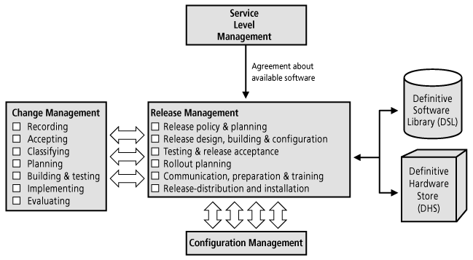
WHY:
IT operations groups continue to struggle with the incorporation of application, infrastructure, and operational changes into their IT production environments. According to Meta Group: through 2008, IT operations groups will increasingly seek to maintain/improve change-management service levels by formalizing and adopting processes that enable improved acceptance of change into the production environment (e.g., production acceptance [PA], production control, quality assurance [QA], release management).
GOAL: The goal of Release Management is to ensure that all technical and non-technical aspects of a release are dealt with in a coordinated approach.
ACTIVITIES:

Release Management activities include:

Release policy and planning

Release design, build and configuration

Release acceptance

Rollout planning

Extensive testing to predefined acceptance criteria

Sign-off of the Release for implementation

Communication, preparation and training

Audits of hardware & software prior to & following the implementation of Changes

Installation of new or upgraded hardware

Storage of controlled software in both centralised and distributed systems

Release, distribution and the installation of software.

Release Management should be used for:

Large or critical hardware rollouts, especially when there is a dependency on a related software Change in the business systems, i.e. not every single PC needs to be installed

Major software rollouts, especially initial instances of new applications along with accompanying software distribution and support procedures for subsequent use if required
- Bundling or batching related sets of Changes into manageable-sized units.
Terminology:
- Major release contains large areas of new functionality NEW VERSION 1.0 → 2.0
- Minor release contains small enhancements and fixes VERSION 1.0 → 1.1
- Emergency fix contains corrections to a small number of Known Errors VERSION 1.0 → 1.0a
- Full Release All components of the Release unit are built, tested, distributed or implemented together.
- Delta Release (Partial Release) – only include CIs that have actually changed or are new
- Package Release Individual releases are combined into a package release

RESULTS:

Key performance indicators

Releases built and implemented on schedule, and within budgeted resources

Very low (ideally no) incidence of Releases having to be backed out due to unacceptable errors + a low incidence of build failures

Secure and accurate management of the DSL (definitive software library) (that only has authorised software)

DSL sizing matching the demand for space, and timely and accurate housekeeping of the DSL

Compliance with all legal restrictions relating to bought-in software

Accurate distribution of Releases to all remote sites

No evidence of use of any unauthorised reversal to previous versions at any site

No evidence of payment of licence fees or wasted maintenance effort, for software that is not actually being used at any particular location

Accurate CMDB update

A post-release review carried out on all Release activities, and all necessary corrective or follow-up action taken, together with any process improvements

The planned composition of Releases matching the actual composition (which demonstrates good Release planning)
COST:
  - Personnel – Release staff
  - Accommodation – Physical location (Set-up and ongoing)
  - Software – Tools (Set-up and ongoing)
  - Hardware – Infrastructure (Set-up)
  - Education – Training (Set-up and ongoing)
  - Procedures – external consultants etc (Set-up)

BENEFITS:

A greater success rate in the Release of hardware and software

Consistency in the Release processes of the hardware platforms or software environments

Minimisation of the disruption of the service to the business

Assurance that the hardware and software in production use is of good (or known) quality

Stable test and live environments

Better use of User resources

Minimisation of regression-testing requirements

Better expectation setting within the organisation on publication of a Release schedule in advance

Error reduction through the controlled Release of hardware and software to the live environment

A complete record (or audit trail) of Changes to the live environment is maintained, both of software distributions and of hardware Changes

Proper control and safeguarding of hardware and software assets, upon which an organisation may be heavily dependent

An ability to absorb high rates of Change to the live systems

The ability to build and control the software used at remote sites from a central location

Savings in support costs through the ability to maintain consistent software over a large number of locations

Reduced likelihood of there being illegal copies of software in use at any location

Easier detection of wrong versions and unauthorised copies of software

Reduced risk of unnoticed introduction of viruses or other malicious software

Reduced time to Release and fewer delays

Fewer Releases to be rolled out to Customers
- Smoother transitions of Releases from the development activities (projects) to the Customer's business environment.

